# **GDD – Train to Teasan**

Contents

GDD – Train to Teasan 1

Project Overview – Train to Teasan 4

1-Line Summary 4

Description 4

Target Market 4

Competitor Analysis 4

Design Pillars 4

Gameplay Design 5

Synopsis of Gameplay 5

Game Mode - Exploration 5

Description 5

Objectives / Goals 5

Game Loops 5

Game Mechanics 5

Mechanics List 6

Movement - Walking 6

Progression – Piece Collection 6

Progression – Tea Making 7

Rules & Systems 7

User Interface & Controls 9

User Interface Design 9

Tea Pot/Silhouette Assembly 9

Dialogue Box UI 9

Inventory UI 9

Feedback Systems 9

Controls 9

Game Content 10

Content Types 10

Cultures/Tea Masters 10

Points of Interest 10

Tea Ware Collection 10

Kintsugi Teapot 10

Project Overview – Train to Teasan

### 1-Line Summary

Explore 3 different tea cultures in a stylistic journey through dream-like tea worlds.

### Description

A first-person narrative game where you are on a train and are approached by tea making strangers, telling you tales about their favourite teas, their experiences and stories as they make tea for you.  
   
As the stories begin from each stranger, the scenery around you changes, transporting you to their experiences and tea making lessons in a dreamlike world.

### Target Market

* Tea Connoisseurs/Enthusiasts
* Casual/Indie Gamers
* Purveyors of diverse cultures

### Competitor Analysis

* There is a lack of tea themed marketing games, and tea-based games in general.
* Of the games that do exist (2; Ampu-Tea and Tea Party, both on Steam) they do not have Tea as an experience but more as a mention and/or incident.
* Other brands have targeted casual gamer audiences like McDonalds, Pepsi, Burger King, etc...
* However, they were met with mixed success, for the most part they were simple to make and play, failing to capture audiences in the long term (long term; allowing to open a potential market for Brands to make Games for their products)

### Design Pillars

* **Cultural Experience** – Learn about unique aspects of different cultures
* **Tea is Real Story -** Our design and game, story is centred around tea/tea is the focus
* **Simplicity and Accessibility** –A focus on easy and simple gameplay for players to immerse in the culture and history of tea

## Gameplay Design

### Synopsis of Gameplay

The player starts in a train carriage, they can see 3 distinct individuals spread out in the train. The player can speak to any of them, the first one to speak to the player welcomes them to the Tea Train and begins to talk about the tea they are preparing and its history and offers it to the player to drink.

The player after having drunk the tea is transported to the dreamworld, a new narration begins that is the personal history of the Tea Master and their relationship with the tea, the player must collect pieces to assemble a tea paraphernalia for the endgame. Once the player has assembled, they are transported back to the real world. The player must complete all 3 dreamworlds to be able to make tea for the Tea Masters at the end and win their approval, then the game ends.

Game Mode - Exploration

Description

Exploration: The player can explore both the carriage and the dreamworld

Objectives / Goals

* **Exploring the Dreamworld**  
  The player must speak to the Tea Masters to be able to explore the Dreamworld
* **Collect the broken pieces**  
  In the Dreamworld, the player must collect all the broken pieces to return to the Real World
* **Making tea for the Tea Masters**  
  Player must complete all 3 Dreamworlds and collect all 3 Tea Ware pieces to make tea for the Tea Masters

#### 

#### Game Loops

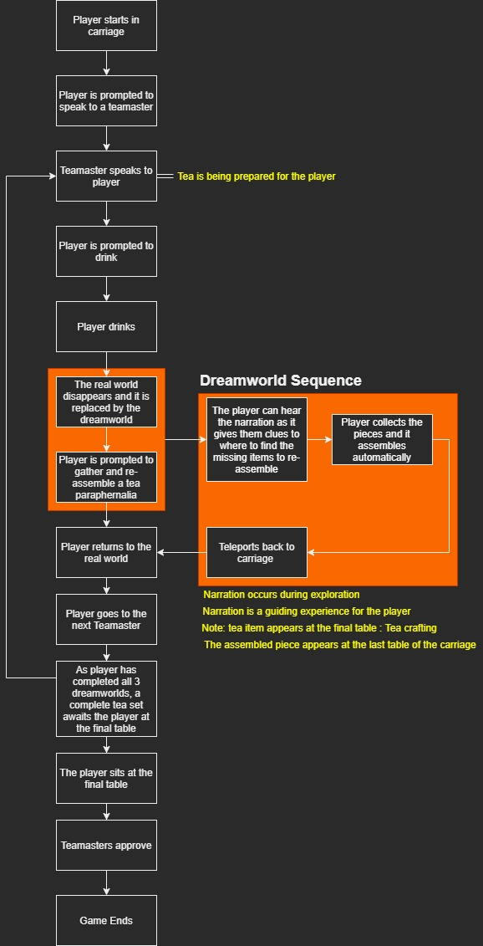

### Game Mechanics

Mechanics List

* Dialogue
  + Player and Tea Master
  + Voice Over during Dreamworld sequence
* Tea Crafting
  + Final Game, player makes tea for Tea Masters
* Object Interaction
* Piece Collection
* Movement

#### Movement - Walking

**Summary: A simple WASD controller for the player to walk through the game**

**Details:**

* No jumping
* No running
* As for the above, we are eliminating any need for frenetic and fast action movements

#### Progression - Piece Collection

**Summary:** Each of the Dreamworld have broken pieces to collect to be able to assemble for a final tea set at the end of the game

**Details:**

* Broken pieces are spread throughout the game in a path
* Once all the pieces are collected

**Related mechanics & systems:**

* Once all pieces are collected and the main piece assembled, it activates the scene transition system
* A hint system is activated if the player is idle for too long or unsure of what to do

#### 

#### Progression – Tea Making

**Summary:** After the player has experienced the 3 dreamworlds, they sit down and make tea for the Tea Masters

**Details:**

* The assembled Tea Ware pieces are found at the end table
* The player has a small interaction with the pieces to make tea
* The game ends after the tea is drunk by the tea masters

**Related mechanics & systems:**

* Sound is played to prompt the player to take a seat
* The level transitions to the tea masters sitting across

### Rules & Systems

**To Explore Dreamworlds**

* For the player to explore the dreamworld, they must speak to the Tea Masters

**Returning to the Carriage**

* For the player to return, they can only do so if they collect the missing pieces in the Dreamworld

## User Interface & Controls

### 

### User Interface Design

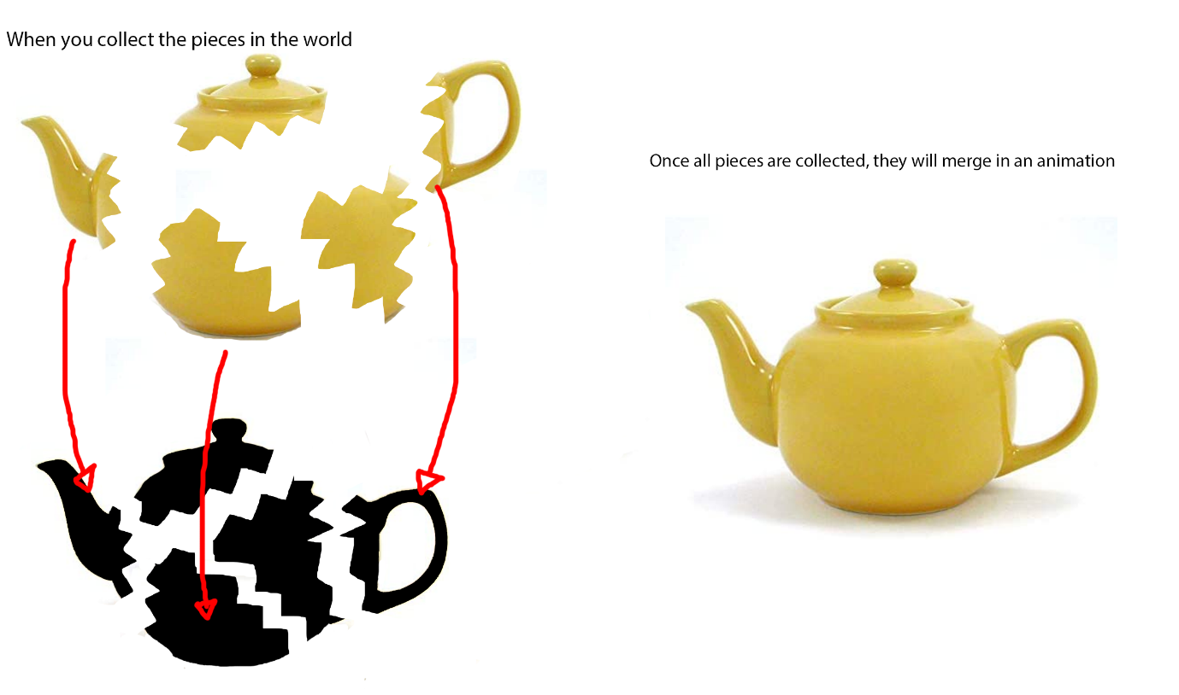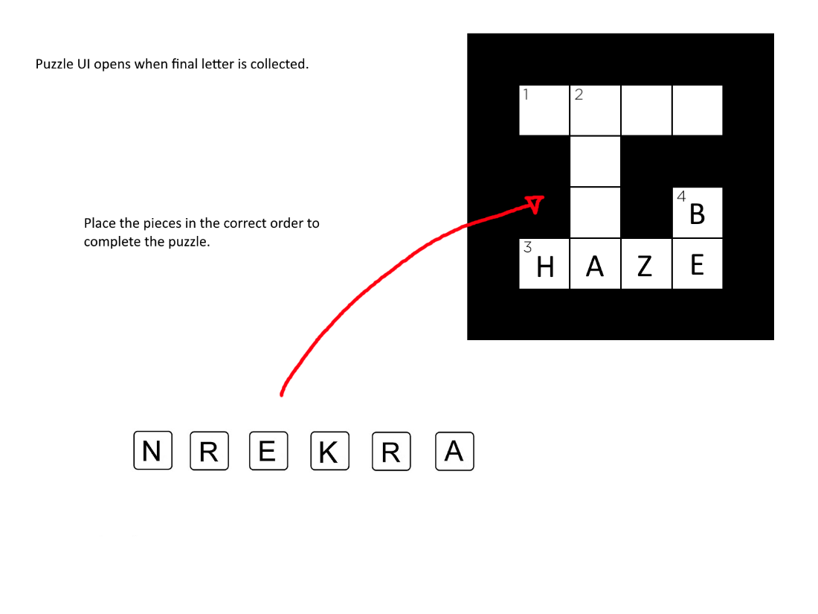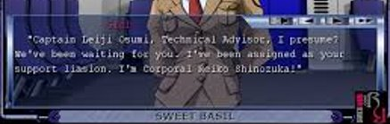

The dialogue box is minimalistic with a translucent background and clear lettering



The collection UI is also simplistic, and in keeping with the minimalistic theme, it will have a translucent background

### 

### Feedback Systems

**The player will receive prompts through sound**

* If the player is near a Tea Master, the Tea Master will ask the player to sit

**The player will also see a text prompt indicating they player can sit**

* Once the player has been asked by the Tea Master, a text can appear telling the player to ‘Sit’

### Controls

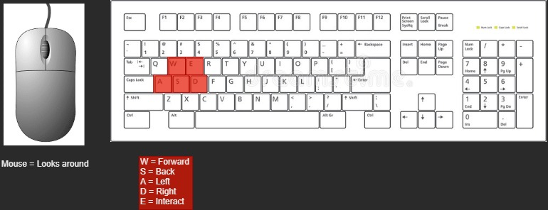

## Game Content

### Content Types

* Cultures/Tea Masters
* Points of Interest
* Tea ware Collection
* Kintsugi Teapot

### Cultures/Tea Masters

Britain Culture

* A British Royal guard

Indian Culture

* Indian Man Tea Man

Japanese Culture

* Geisha

### Locations

Train carriage interior

British Garden

* Hedge Maze
* Fountain
* Cottage

Indian Garden

* Elephant Statue (animal)
* Traditional Style Stall (Spice)
* Gate/Stairs (Sun Temple)

Japanese Garden

* Pagoda
* Cherry Blossom Tree
* Japanese gate

### Collection - Tea ware

Kintsugi Teapot

A traditional Japanese teapot that has been broken. The player will repair it using the kintsugi method, which celebrates the history and the cracks instead of concealing them.

* Used the make tea at the end of the game.

Indian Saucer and Spoon

Humble clay looking Saucer and metal long spoon themed to the puzzle and culture